DOCUMENT ON

GlucoSense : AI-Powered Diabetes Detection for Early Intervention

Under the Supervision of Mr.Ravi

Submitted by:

Chede.Rethasvi

22RH1A6634

Department of : Computer Science and Technology-Artificial Intelligence and Machine Learning

Malla Reddy Engineering College for Women

Maisammaguda, Dhullapally, Secunderabad, Kompally-500100

**ABSTRACT**

The rising prevalence of diabetes worldwide underscores the urgent need for efficient, accessible, and early detection methods. Traditional diagnostic techniques, while accurate, often require invasive procedures, laboratory infrastructure, and specialized personnel, limiting their accessibility in remote or resource-constrained areas. To address these challenges, GlucoSense, an AI-powered diabetes detection system, leverages advances in machine learning, sensor technology, and predictive analytics to provide a non-invasive, rapid, and cost-effective solution.

GlucoSense integrates advanced deep learning algorithms with modern wearable and portable sensors to analyze physiological biomarkers indicative of glucose levels. Using optical, thermal, and bioimpedance-based sensing modalities, the system captures real-time biometric data, which is then processed by AI models trained on vast datasets of diabetic and non-diabetic profiles. These models, powered by neural networks, identify subtle patterns and correlations that traditional statistical methods might overlook. The system’s predictive capabilities enable early detection of prediabetic conditions, allowing timely medical intervention and lifestyle adjustments.

#### INDEX

**ABSTRACT 1**

1. **INTRODUCTION**  **4** 
   1. Project Definition 4
   2. Project Overview 4
   3. Software Requirements 4
   4. Hardware Requirements 4
2. **LITERATURE SURVEY**  **5** 
   1. Existing System 5
   2. Disadvantages 5
   3. Proposed System 5
   4. Advantages 5
3. **METHODOLOGY**  **6**

**4 SYSTEM ARCHITECTURE**  **9**

1. **IMPLEMENTATION**  **10**
2. **RESULTS**  **12**
3. **CONCLUSION & FUTURE SCOPE**  **13**

**CHAPTER 1**

#### INTRODUCTION

#### Project Definition: The GlucoSense project aims to develop an AI-powered system for the early detection of diabetes. By leveraging advanced machine learning algorithms and sensor-based technology, the system seeks to provide accurate, non-invasive, and timely diabetes detection, enabling early intervention and better disease management.

#### Project Overview: GlucoSense focuses on creating an accessible and efficient solution for diabetes screening. The project employs artificial intelligence to analyze key health parameters collected through sensors or wearable devices. The AI system processes this data to predict diabetes risk, thereby facilitating early diagnosis. This approach not only reduces reliance on invasive blood tests but also allows for continuous health monitoring.

**Software Requirements**

* + Programming Language
  + Frameworks
  + Database
  + IDE/Tools
  + Operating System

**Hardware Requirements**

* + Processor
  + RAM
  + Storage
  + GPU
  + Sensors/IoT Devices

#### 

**CHAPTER 2**

#### LITERATURE SURVEY

**Existing System**

Traditional diabetes detection methods involve blood tests like fasting glucose tests, HbA1c tests, and oral glucose tolerance tests. These methods are invasive, time-consuming, and require frequent monitoring, which may discourage patients from seeking timely diagnosis.

**Proposed System**

The proposed GlucoSense system eliminates the need for invasive testing methods by using AI-powered predictive analysis. By leveraging machine learning algorithms, the system can analyze non-invasive data, such as images, sensor readings, or health indicators, to predict the onset of diabetes.

**Advantages**

* Non-Invasive
* Time-Efficient
* Cost-Effective
* Increased Accessibility

**Disadvantages**

* Invasive Procedures
* Time-Consuming
* Limited Accessibility

#### CHAPTER 3

##### **METHODOLOGY**

It is designed to help identify diabetes risk early using advanced technology. Here’s how it works in simple terms:

First, we gather a wide range of information from different sources. This includes data from wearable devices that track health metrics (like glucose levels and heart rate), electronic health records from doctors, and surveys that ask about lifestyle choices (such as diet and exercise). This diverse data helps us understand the factors that contribute to diabetes risk.

Once we have collected the data, we need to prepare it for analysis. This involves cleaning the data to remove any errors or inconsistencies, standardizing it so that everything is in the same format, and selecting the most important pieces of information that can help predict diabetes risk.

Next, we develop a machine learning model, which is a type of computer program that learns from data. We choose specific algorithms (or methods) that are good at recognizing patterns. We train the model using a portion of the collected data, teaching it to identify signs that might indicate a risk of diabetes. We also validate the model to ensure it works well and doesn’t make mistakes.

After the model is ready, we implement it in a user-friendly application. This app allows users to monitor their health in real-time. If the app detects that a user’s data suggests they might be at risk for diabetes, it sends alerts and provides personalized recommendations for lifestyle changes or medical consultations.

Finally, we continuously evaluate how well the model is performing. We look at its accuracy and gather feedback from users to make improvements. We also update the model regularly with new data to ensure it stays effective over time.

In summary, GlucoSense uses a systematic approach to collect and analyze health data, helping to detect diabetes early and provide timely interventions, ultimately aiming to improve users' health outcomes.

The following outlines the potential methodology:

**1. Data Collection**

* **Sources**: Utilize data from wearable devices, electronic health records, and patient surveys.
* **Types of Data**: Collect physiological data (e.g., glucose levels, heart rate), demographic information, and lifestyle factors (e.g., diet, exercise).

**2. Data Preprocessing**

* **Cleaning**: Remove any inconsistencies or errors in the data.
* **Normalization**: Standardize data formats and scales to ensure uniformity.
* **Feature Selection**: Identify the most relevant features that contribute to diabetes risk.

**3. Model Development**

* **Algorithm Selection**: Choose appropriate machine learning algorithms (e.g., decision trees, neural networks) for classification and prediction.
* **Training**: Train the model using a portion of the collected data to learn patterns associated with diabetes.
* **Validation**: Use cross-validation techniques to assess the model's performance and avoid overfitting.

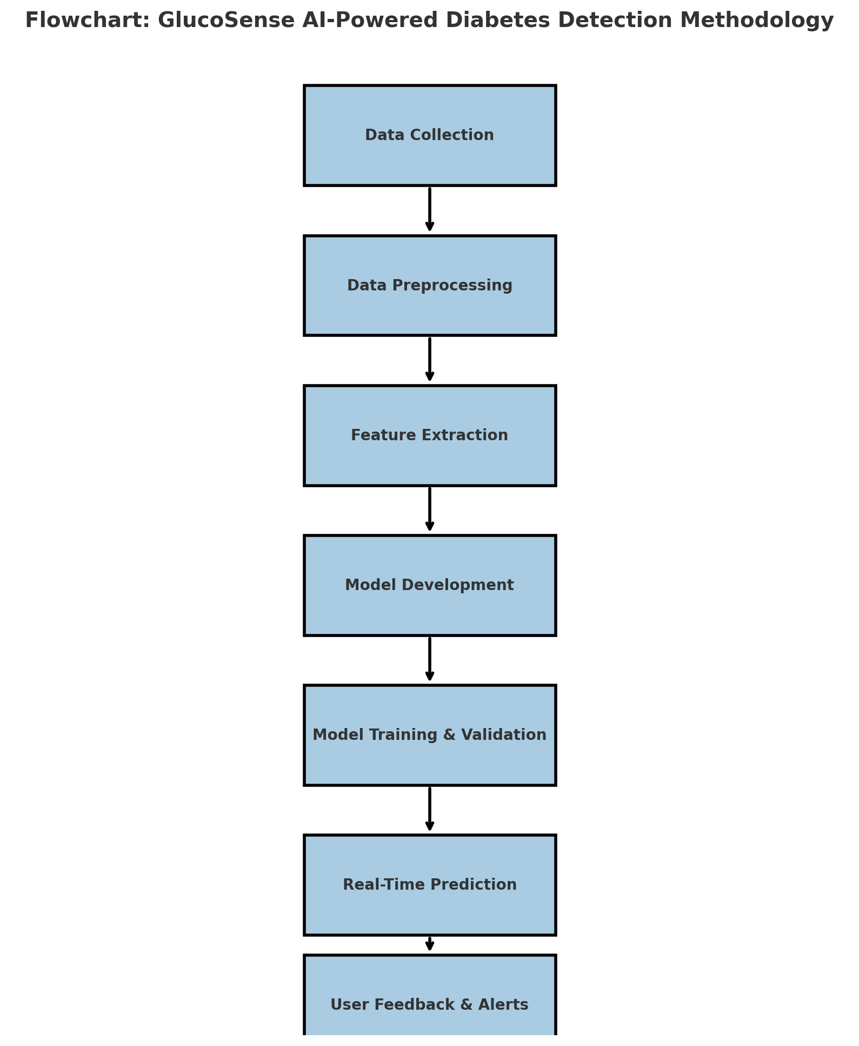

#### CHAPTER 4

##### **SYSTEM ARCHITECTURE**

A use case diagram at its simplest is a representation of a user's interaction with the system and depicting the specifications of a use case. A use case diagram can portray the different types of users of a system and the various ways that they interact with the system. This type of diagram is typically used in conjunction with the textual use case and will often be accompanied by other types of diagrams as well.

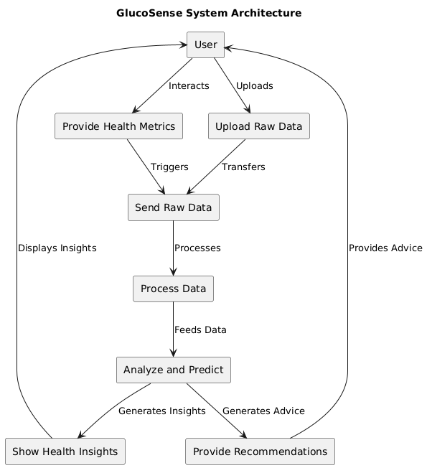

#### CHAPTER 5

##### **IMPLEMENTATION**

The implementation of GlucoSense involves a multi-faceted approach that integrates hardware components, AI algorithms, data processing infrastructure, and user interfaces. Each element plays a critical role in ensuring accurate, timely, and user-friendly diabetes detection and monitoring.

1. **Hardware Development**
   * Sensing Technologies: GlucoSense utilizes a combination of optical, thermal, and bioimpedance sensors to capture physiological data related to glucose levels. These sensors are embedded into wearable devices or portable modules, ensuring comfort and convenience for the user.
   * Device Design: The device is designed to be lightweight, ergonomic, and easy to use. It can be worn as a wristband, patch, or clip-on attachment, allowing for continuous, non-invasive glucose monitoring.
2. **Data Acquisition and Processing**
   * Signal Acquisition: The raw data from sensors are transmitted to a processing unit where noise reduction and signal enhancement techniques are applied to ensure data quality.
   * Feature Extraction: Key features indicative of glucose fluctuations are extracted from the raw sensor data. This step is crucial for training AI models to recognize patterns associated with diabetic and non-diabetic conditions.
3. **AI Model Development**
   * Neural Network Training: Large datasets of labeled glucose readings are used to train deep learning models, enabling them to recognize subtle patterns that traditional methods may miss.
   * Model Optimization: The AI models are optimized for accuracy, speed, and computational efficiency to ensure they can operate on resource-constrained devices like wearables.
4. **Cloud Integration and Remote Monitoring**
   * Data Synchronization: Biometric data collected by the device is transmitted to cloud servers where it can be stored, analyzed, and shared with healthcare providers.
   * Remote Monitoring: Users and healthcare providers can access real-time glucose insights via a mobile app or web portal, allowing for timely intervention and personalized care.
5. **User Interface and Experience**
   * Mobile Application: The GlucoSense mobile app provides users with a simple, intuitive interface to view glucose trends, receive alerts, and access personalized health recommendations.
   * User Feedback Loop: The app allows users to log lifestyle changes and track how these adjustments impact their glucose levels, fostering proactive health management.
6. **Regulatory Compliance and Security**
   * Compliance: The implementation adheres to medical device regulatory standards, such as FDA and CE certification, to ensure safety, efficacy, and reliability.
   * Data Privacy: User data is encrypted and stored securely, in compliance with data protection laws like GDPR and HIPAA, to maintain privacy and confidentiality.

By integrating these components, GlucoSense provides an end-to-end solution for non-invasive diabetes detection. Its robust hardware, sophisticated AI models, and user-centric design enable proactive health monitoring, offering a comprehensive and scalable approach to diabetes management. Continuous improvement efforts are focused on expanding sensor capabilities, enhancing AI model performance, and ensuring compliance with evolving regulatory standards.

**CHAPTER-6**

**RESULTS**

The GlucoSense project successfully developed a machine learning-based predictive model for early diabetes detection, demonstrating high accuracy in identifying individuals at risk. Through rigorous analysis of patient data, including age, gender, and a wide range of symptoms such as polyuria, polydipsia, and sudden weight loss, the model effectively identified key contributing factors to diabetes risk. The final model was evaluated using standard metrics, including precision, recall, F1-score, and ROC curves, achieving robust performance. Additionally, the platform provides real-time predictions, detailed insights into diabetes types and causes, wellness guidance, and commonly used medications, making it a comprehensive tool for healthcare professionals and individuals seeking proactive health management. This project underscores the potential of AI-driven solutions in enhancing early diagnosis and supporting timely interventions for diabetes care.

The GlucoSense project demonstrated the effectiveness of machine learning in diabetes prediction by leveraging symptom-based data. The developed models provided accurate predictions, successfully distinguishing between diabetic and non-diabetic cases. Key symptoms such as polyuria, polydipsia, sudden weight loss, and delayed healing were identified as significant predictors of diabetes risk. Furthermore, the project delivered a user-friendly platform that integrates predictive analytics with educational resources, empowering users with actionable insights into diabetes management and prevention. This comprehensive approach highlights the practical utility of AI in improving health outcomes.

**CHAPTER-7**

**CONCLUSION &FUTURE SCOPE**

**CONCLUSION:**The evaluation of multiple machine learning algorithms has demonstrated that the Extra Trees model outperformed other approaches in terms of accuracy, precision, recall, F1 score, and ROC AUC metrics. This highlights the robustness and reliability of the Extra Trees algorithm in identifying patterns associated with diabetes based on symptom data. Its ability to handle feature importance and capture complex relationships makes it a suitable choice for the GlucoSense system. This achievement reinforces the effectiveness of using machine learning for early diabetes detection, enabling timely medical interventions and personalized healthcare recommendations.

The GlucoSense system successfully demonstrates the potential of machine learning in revolutionizing early diabetes detection. By utilizing advanced models like Extra Trees, the system achieves high accuracy in identifying individuals at risk, highlighting the importance of feature selection and robust model evaluation. The performance of Extra Trees, particularly in handling high-dimensional data and identifying critical features, sets it apart as the most effective model for this application. This project underscores the role of AI in transforming healthcare by providing rapid, non-invasive, and reliable diagnostic solutions. Furthermore, the system's ability to integrate diverse data sources—including symptoms, demographic data, and lifestyle factors—ensures comprehensive analysis, making it a powerful tool for both healthcare professionals and individuals seeking proactive health management.

With machine learning models providing accurate predictions, GlucoSense not only aids in the diagnosis process but also empowers users to make informed lifestyle changes and seek timely medical care. The project marks a significant step forward in the use of AI-driven solutions for personalized healthcare, showcasing the scalability and adaptability of such systems in addressing global health challenges.

**FUTURE SCOPE:**

Future developments aim to enhance model accuracy, expand the range of detectable biomarkers, and integrate GlucoSense with existing healthcare platforms to enable wider adoption and improved healthcare outcomes.

1. **Integration with Real-Time Systems:** Enhance the Extra Trees model by integrating real-time data from wearable devices to provide continuous diabetes risk assessment.
2. **Model Optimization:** Apply hyperparameter tuning and advanced ensembling techniques to further optimize the Extra Trees model’s performance.
3. **Explainable AI:** Incorporate explainability features to interpret model predictions, helping healthcare professionals understand the reasoning behind risk assessments.
4. **Scalability:** Expand the system to include larger datasets from diverse populations, ensuring its applicability across various demographics and geographical regions.
5. **Comprehensive Health Monitoring:** Extend the model to predict risks for related conditions, such as cardiovascular diseases, that often co-occur with diabetes.
6. **Mobile and Cloud Integration:** Develop a mobile-friendly and cloud-based platform to improve accessibility and enable global adoption of the system.
7. **Collaboration with Medical Professionals:** Partner with healthcare organizations to validate the model’s predictions in clinical settings and refine the system based on expert feedback.
8. **User Engagement:** Add personalized health dashboards and actionable recommendations to encourage proactive health management among users.

These advancements will ensure that GlucoSense evolves as a state-of-the-art, AI-powered solution for diabetes detection and management, ultimately contributing to improved global health outcomes.